257 Lone Oak Place
Langford, Victoria, BC

Builder Specification Highlights

Square footage:
- Upper floor: 1676 SqFt
- Lower floor: 1290 SqFt
- Garage: 419 SqFt
- Total: 3385 SqFt

- Secondary Suite: 603 SqFt

BASEMENT & FOUNDATION
  - Exterior damp proofing
  - Weeping tile around foundation of house
  - Insulated concrete form foundation and slab

FRAMING FEATURES
Floors
  - ¾" OSB Tongue & Groove subfloor screwed and glued down
  - Engineered floor joist system

Exterior Walls & Garage
  - 2" × 6" lumber 16" O.C.

Interior Walls
  - 2" × 4" lumber 16" O.C.
  - 2" × 6" lumber for load bearing or plumbing walls
  - Sealed top and bottom plate to minimize heat loss

Stairs
  - Solid staircase with coordinated finishing material

EXTERIOR FINISH
Front
  - Hardy panel/planks with metal long board cladding

Soffit/Fascia
  - Pre–finished aluminium black soffit, eavestroughs, fascia, and black downspouts

Windows
  - Double pane vinyl windows

DOORS
  - Insulated fibreglass 8’ front entry with glass feature
  - Weiser door handle with deadbolt front locks

ELECTRICAL
  - 2 exterior weatherproof ground fault plugs on separate circuits
  - 4 TV & 4 CAT-6 outlets throughout
  - 2 telephone jacks prewired – rough in only (master & kitchen)
  - Early warning smoke detectors direct wired on all levels & every bedroom
  - Carbon monoxide detector installed outside all sleeping areas
  - 220-volt stove & dryer plug
  - Garage door opener with 2 remotes and exterior access pad
  - Bathroom G.F.I. outlets
  - Electronic set back thermostat
  - Range hood vented to exterior
  - Vacuum rough-in

HEATING SYSTEM
  - 95.5% efficient furnace
  - 10-year warranty on furnace parts and 5 years on labor
  - HRV (heat recovery ventilation system)
  - Galvanized heating ducts
  - Heat Pump
  - Dryer vent to outside
  - In floor heating in Ensuite Bathroom

INTERIOR FINISHING
  - 3" painted casings and 4.5" baseboards
  - Painted oak handrails with glass railing
  - Vanity mirrors in all bathrooms
  - MDF shelving in all closets and mud room
  - Interior doors are 8 feet high
  - Secura lever door handles in black finish
  - Gas fireplace comes with electronic ignition
  - Main floor to ceiling height 9 feet
  - Second floor to ceiling height 9 feet
  - Ceramic tile in bathrooms, and laundry room
  - Ceramic tile full height in shower and tubs
  - Quartz kitchen and bathroom counters and 8’ island
  - Free Standing Tub with black water faucet

CABINETS
  - Custom cabinetry and vanities as per plan and design
  - Under cabinet LED valence lighting and puck lights in kitchen cabinets
  - Soft close doors and drawers throughout
  - Quartz counters throughout
  - Island with waterfall
  - 36" refrigerator space
  - Wine Cabinetry built in

HARDWARE
  - Black Colour passage and privacy lock sets
  - Black bath hardware
  - Secura Privacy locks in baths and bedrooms

INTERIOR/EXTERIOR & CEILING FINISHES
  - Spray foam around all windows and doors
  - ½" drywall floor to ceiling screwed
  - ½" drywall on ceiling
  - Double 5/8” fire separation drywall and insulated between main house and suite
  - Caulking applied to top and bottom plates
  - Painted main floor ceilings
  - Garage is insulated, boarded, and taped

PLUMBING
  - Kitchen has undermount double stainless-steel sink with single lever tap equipped with pull out vegetable sprayer
  - Bathrooms equipped with black faucets
  - Guest bathrooms include acrylic tub
  - Showers with temperature control valves
  - 50-gallon electric hot water tank, high efficiency, and power vented (if in floor heating is selected then there will be hot water on demand along with a hot water holding tank.)
  - Aqua PEX ½" water lines with ¾" main lines
  - 2 exterior lawn services
  - Sewer backup water valve
  - Standard pipe drains and tap for washer – location as per plan
  - Shut off valves on all toilets, sinks, and hose bibs
  - Garburator under kitchen sink
  - Gas line to rear deck for BBQ, Firepit and cooktop
  - Water line to fridge
  - Undermount vanity sinks in all bathrooms
  - Low flow, raised height toilets
  - Ensuite shower with 10 mm frameless glass swing door

EXTERIOR
  - Broom finished rebar reinforced driveway
  - Broom finished front entry step & sidewalk
  - Landscaping in the front with tree, sprinkler, sod and bushes
  - Aluminium Glass Exterior railing for front and back deck
  - Lot will have final grade completed with topsoil. If owner wishes to have builder finish landscaping, that will be an additional cost.

MISCELLANEOUS
  - Stainless steel kitchen appliances (see below)
  - Washer and Dryer for main house in laundry room

ADDITIONAL INCLUDED ITEMS:

- White Barn Door on Ensuite Bathroom Entrance
- Tankless Water Heater valued at $2500
- Front Exterior includes Concrete Driveway, Sod, One Tree
- Back Exterior includes only top soil
- White Washer Dryer in main house
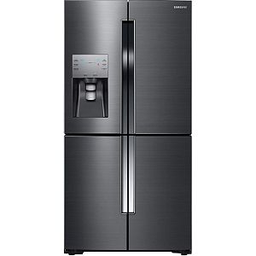

Samsung36-inch W 22.5 cu. ft. French Door Refrigerator in Fingerprint Resistant Black Stainless - ENERGY STAR®
Model: RF23J9011SG

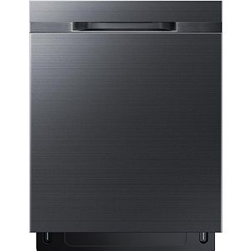

Samsung24-inch Top Control Dishwasher in Black Stainless Steel with Stainless Steel Tub - ENERGY STAR®, 48 dBA
Model: DW80K5050UG

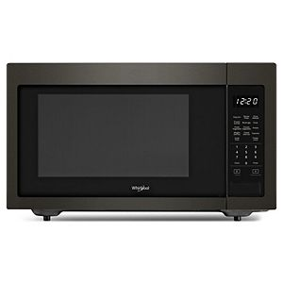

Whirlpool1.6 cu. ft. Countertop Microwave in Black Stainless Steel
Model: YWMC30516HV

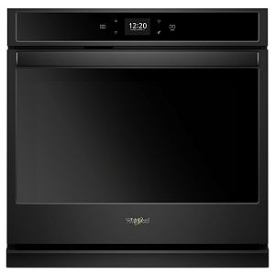

Whirlpool30-inch 5.0 cu. ft. Smart Single Electric Wall Oven Self-Cleaning with Touchscreen in Black
Model: WOS51EC0HB

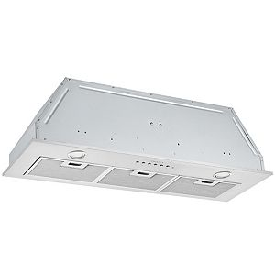

AnconaBNL436 36-inch 420 CFM Built-in Ducted Range Hood with Night Light Feature
Model: AN-1317

Plans and prices are subject to change without notice. The builder reserves the right to change material or specifications without notice but guarantees that change will be of equal or greater value. Room dimensions are approximate. Windows in cantilevers and size of cantilevers are subject to side yard restrictions. Garage dimensions are exterior. Illustrations are artist concepts and may vary.

